Vidya Pratishthan’s

**ARTS, SCIENCE AND COMMERCE COLLEGE**

**Baramati, Dist-Pune-413133**

# **A PROJECT REPORT ON**

“diGitaL nOtiCE BOard”

**FOR**

# Vidya Pratishthan’s

**ARTS, SCIENCE AND COMMERCE COLLEGE, BARAMATI. SUBMITTED TO**

## UNIVERSITY OF PUNE BY

**Kale Ranjit Gajanan Kakade Akash Chandrakant**

**Roll NO: 059 Roll NO:057**

## YEAR 2022-23

CERTIFICATE

This is certify that **Kale Ranjit Gajanan** and **Kakade Akash Chandrakant** of class **TY**

**B.Sc(cs)** has successfully completed the project

“**DIGITAL** **NOTICE** **BOARD**” for **vidya pratishtan’s**

**Arts Science and Commerce college,Baramati,** as a part of practrical fulfillment of lab course according to **Savitribai phule Pune University** during academic year 2021-22.

**Mrs.Kadam Trupti T. Prof.Gajanan Joshi**

**Project Guide HOD**

# **Index**

|  |  |
| --- | --- |
| **Sr.No** | **Title** |
| 1 | System Introduction |
| 2 | Problem Defination |
| 3 | Acknowledgement |
| 4 | Existing system and need for the new system |
| 5 | Scope of System |
| 6 | Operational Environment I.Software Requirement  II.Hardware requirement |
| 7 | Feasibility Study   1. Technical Feasibility 2. Economical Feasibility 3. Operational Feasibility |
| 8 | Entity Relationship Diagram(ERD) |
| 9 | Data Dictionary |
| 10 | UML Diagram   1. Use class Diagram 2. Class Diagram 3. Sequance Diagram 4. Activity Diagram |

## INTRODUCTION

The lifestyle of people is changing drastically, from online shopping to internet banking, online admissions to e-mark sheets, e-learning to e-certificates, websites to mobile applications, etc. Everything is computer based that people don’t have to physically relocate. They can access the things from any place, anywhere without worrying of time and availability. The world is tremendously developing and going digital then why should the notice boards of college still remain as it is? The notice board plays a vital role in student’s life so it also requires some refinement.

Hence the “Digital-Notice Board” is developed as per seeing the increasing requirement to speed up the work and incorporate new work culture. The proposed system which has been developed is to reduce the drawbacks of existing system and make life simple.

The notice board acts like an interface between students and teachers. Due to this, the teacher can communicate with students regarding any new updates or news. The proposed system intends to create a platform for issuing notices, sharing information with all the students. The proposed system would be able to create user friendly GUI for better interaction and communication between each other. The notices can be added by the admin of the system and students have to register prior to check the notices.

## ProblemDefinition

Digital Notice Board System application is used is to display notices to student posted by teacher .Student can read the notice. By using this application we can maintain notice records of various classes.

Primary task of this project is store the teacher and student information into database and only notice teacher can post notices.

By this application teachers can easily communicate with students and vice versa.

### Acknowledgement

It is our privilege to express our sincerest regards to our project guide,

**Mrs.Trupti kadam** for their valuable inputs, able guidance, encouragement, whole-hearted cooperation and constructive criticism throughout the duration of our project.

We deeply express our sincere thanks to our Head of Department

**Prof.Gajanan joshi** for encouraging and allowing us to present the project on the topic "**Digital Notice Board**"at our department premises for the partial fulfilment of the requirements leading to the award of SY B.Sc(Computer Science) degree

We take this opportunity to thank all our lecturers who have directly or indirectly helped our project. We pay our respects and love to our parents and all other family members and friends for their love and encouragement through out our career. Last but not the least we express our thanks to our friends for their cooperation and support.

### Existing System

Initially, the notice board was physical that means students had to actually go and find the notice board to view the latest notices. It resulted in a quite chaotic situation. Even the person who wanted to share the notice he/she had to take a print out or write it manually using paper and pen and display on that physical notice board. The existing system forces both student and teacher/admin to physically move from the original place to view the notices. This consumes a lot of time for both of them. If incase the teacher displays notice on notice board which is quite important and urgent response has to be taken from students then it’s difficult for students to know about it, as there is no way that students are informed that some notice has been displayed on the board. This was kind of troublesome situation for both student and teacher.

The notices displayed on physical notice board were paper based which means there are chances of paper getting ripped, untidy, etc which may have resulted in unreadable data. So the message would never reach students. If any student remains absent then it was difficult for him to get to know about the updates from his college as he had to physically go to college and check the notice board. It sounds bit shaky as it takes quite a long time. In this modern era of everything computer based, this system results in incontinent approach.

### Need of the System

* In this era, almost everything is digital except few things like notice boards. There is no proper attention given to it to make it digital.
* There are institutes that use social networking sites for communicating with students which is not as reliable as it would be by creating a website intended only for notices.
* It is very necessary to become digital these days as it reduces manual work and to make life quite simpler.
* To replace physical notice boards with e-notice boards for efficiency and durability.
* To reduce the manual work which includes writing manually the notices or taking print outs or visiting personally to notice board for checking notices
* To create great interface between faculties of colleges or intended institutes and the respective students.
* To view notices and sort notices according to time so that it becomes more precise for admin as well as students

**OPERATING ENVIRONMENT:**

* **SOFTWARE**

Front end: PHP,Bootstrap

Back-end: Mysql

Operating System: Linux

* **HARDWARE:**

Memory: 150 MB

Hard disk: 1 GB

**Feasibility Study**

* A feasibility study is an analysis of how successfully a project can be completed, accounting for factors that affect the project.
* The outcome of this study is use to determine the potential positive and negative outcomes before investing time , money and human resource on the project.
* The main factors affecting are technical ,economic and operation factors

1. TECHNICAL FEASIBILITY

* Technical Feasibility refers to whether the software available in the market supports the present system.
* It studies the pros and cons of using a particular system for the development and its feasibility.
* It also studies the additional training needed to be given to the people to make the system work.

2. ECONOMIC FEASIBILITY

* It refers to the benefits or outcomes we are deriving from the system as compared to the total cost we are spending for developing the system.
* If the benefits are more or less the same as the older system, then it is not feasible to develop the product.

3. OPERATIONAL FEASIBILITY

* Operational feasibility refers to the feasibility of the system to be operational.
* Some system may work very well at the time of design and implementation but may fail in real environment.

#### UML DIAGRAMS

##### Entity – Relationship Diagram(ERD)

M

1

Student

Rno

Name

Class

Email

Password

M

M

View

Add

Admin

Logid

Password

N

ame

N_id

Title

Detail

Class

Timestamp

**Data Dictionary**

###### Students

|  |  |  |
| --- | --- | --- |
| **Name** | **Data Type** | **Constraints** |
| Roll_no. | int | Primary key |
| U_name | varchar(100) | Not Null |
| Class | varchar(50) | Not Null |
| Email | varchar(100) | Not Null |
| Password | varchar(50) | Not Null |
| Question | varchar(100) | Not Null |
| Answer | varchar(100) | Not Null |

###### Staff

|  |  |  |
| --- | --- | --- |
| **Name** | **Data Type** | **Constraints** |
| a_id | int | Primary key |
| Pass | Varchar(50) | Not Null |

###### Notification

|  |  |  |
| --- | --- | --- |
| **Name** | **Data Type** | **Constraints** |
| Id | int | Primary key |
| Title | varchar(100) | Not Null |
| Details | varchar(100) | Not Null |
| Class | varchar(50) | Not Null |
| Time | date | Not Null |
| Name | varchar(100) | Not Null |

#### CLASS DIAGRAM

+

View_Notices ()

Add_Notices ()

+

Sort_Notices ()

+

Update_Profile ()

+

+

Update_Password ()

Sort

Inserts

Deletes

Student

#

Rno

:

int

Name: varchar (50)

+

+

Class: option

#Email: varchar (20)

-

Password: text

+

View_Notices ()

+

Sort_Notices ()

+

Update_Profile ()

+

Update_Password

()

Admin

#

Log

_id: varchar (20)

-

Password: text

Notice

-

N_id

int

:

#Title: varchar (30)

#Detail: varchar (100)

#Class: option

-

Time: timestamp

M

1

M

M

View

Sort

#### USE CASE

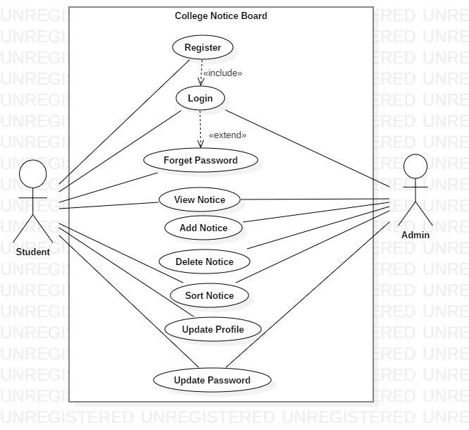

**SEQUENCE DIAGR**

**AM**

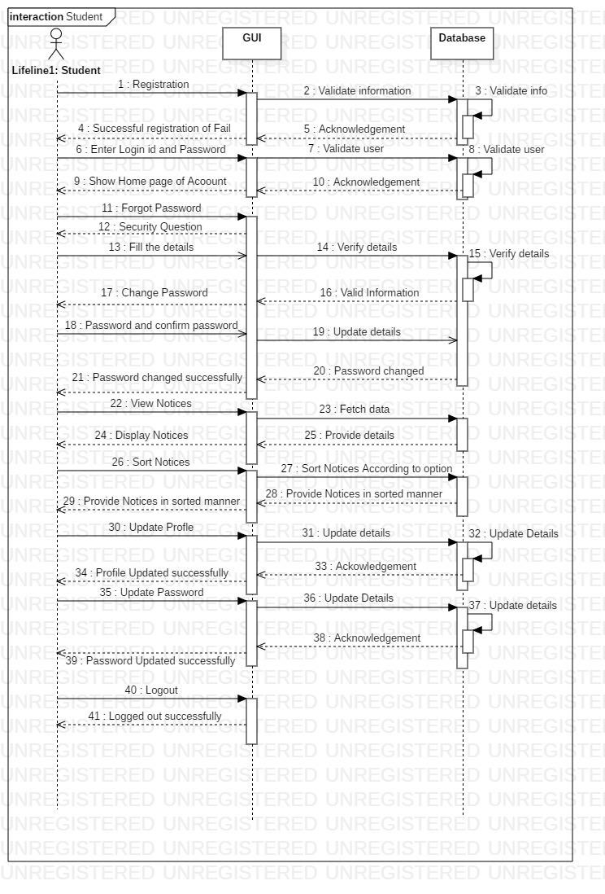

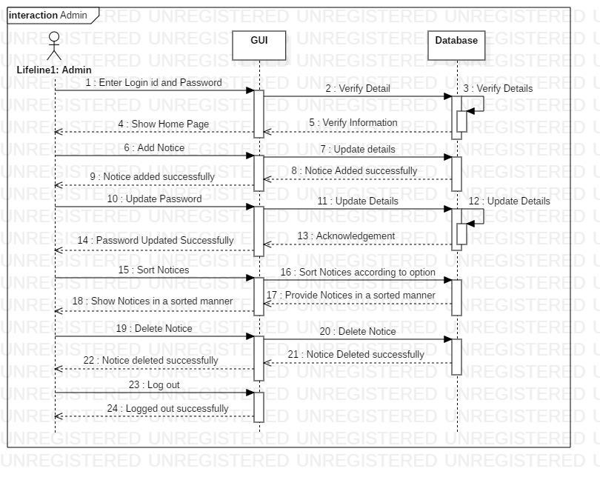

##### **Activity Diagram**

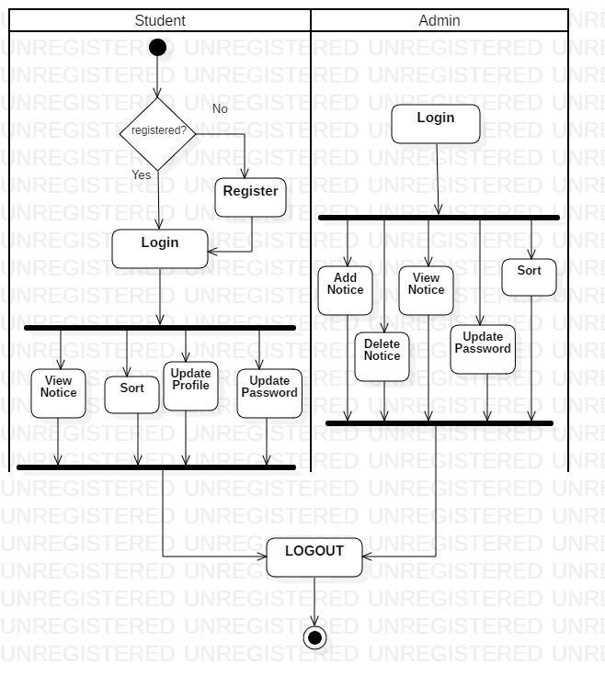

##### ADVANTAGES

* It is not required to go at college Notice Board to check information regarding any event or notice
* The admin can upload any type of messages on the notice board.
* Student can easily go through the notices through their logins.
* Provides user friendly GUI and easy to use ➢ Provides efficiency and better performance

##### DRAWBACKS & LIMITATIONS

* Multiple colleges cannot use the same website
* It is only limited to Fergusson College Department of Computer Science
* Documents cannot be uploaded.